Initial Equity Volatility
In GEMS, the Equity Model has a stochastic volatility (see second row of Equation 1). As with any stochastic model, this will require an initial value. However, unlike the Treasury model, this value is NOT directly derivable from market data.
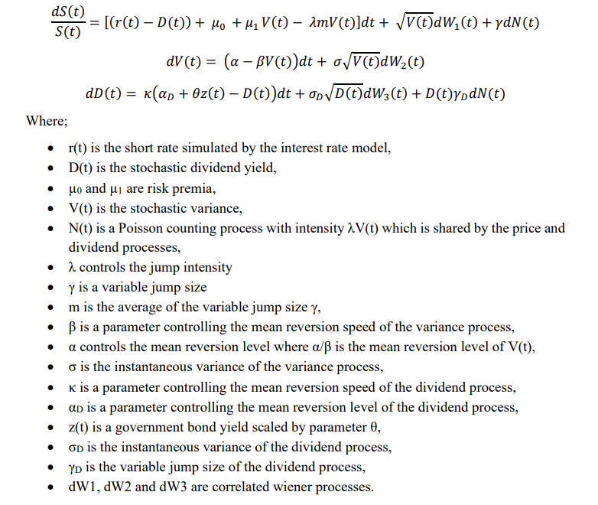
Equation 1: Key GEMS Equity Equations

There are three potential approaches for setting this initial value which this document will discuss:
- Setting it to the model’s long-term level
- Using the standard GEMS calibration methodology
- Using market data to create a proxy

Setting to the Model’s Long-Term Level
Like GEMS, the current AIRG has the same issue: its equity’s volatility is stochastic, so it needs to be initialized. In the AIRG, that is accomplished by setting the initial level to the model’s long-term level. In GEMS, this would mean setting the V(0) in the above equation to α / β.
This approach has several advantages. First, since it means that this parameter is not changing from one run to the next, it will create the most stable return distribution from one run date to the next. Second, since the initial will be set to the long-term level, there will be no trend in volatility across simulation years. Finally, as mentioned above, this assumption would best align with the one that the AIRG currently uses.
There are a few downsides to this approach. First, this approach is inconsistent with how the GEMS model is calibrated. While there may not be directly observable data for this parameter, it is related to recent market movements. Specifically, when the market sees large daily movements like it did in March 2020, the GEMS calibration will tend to lead to an increasing level for this parameter (see Table 1). Second, when companies perform future reserve and capital calculations (i.e. stochastic on stochastic), there will be a disconnect between the outer loop, which will use the above equations, and the inner loop, which will revert to a fixed level.

Use the current Conning methodology
As part of its calibration process for this model, Conning has developed a calibration methodology. This process creates an estimate of this volatility parameters based on the observed daily price fluctuations. Currently, all of the scenarios that have been created by Conning have used the initial value from this process. The amount of fluctuation of this parameter can be seen in Table 1. While the impact of changes in this parameter can be quite large in early periods (e.g. Figure 1 shows Year 1 impact of 3 different initial volatility parameters), Figure 2 shows that this impact tends to fade relatively quickly.

Quarter | GEMS Method | Daily Volatility during the Quarter | Fitted based on Trading Data
1Q 2020 | 1.28% | 3.59% | 1.37%
2Q 2020 | 1.24% | 2.01% | 1.06%
3Q 2020 | 0.91% | 1.07% | 0.88%
4Q 2020 | 0.89% | 1.03% | 0.87%
1Q 2021 | 0.84% | 1.00% | 0.86%
2Q 2021 | 0.67% | 0.70% | 0.80%
Long-Term | 1.40% | N/A | N/A
Table 1: Initial Volatility Values under 2 alternative Methods
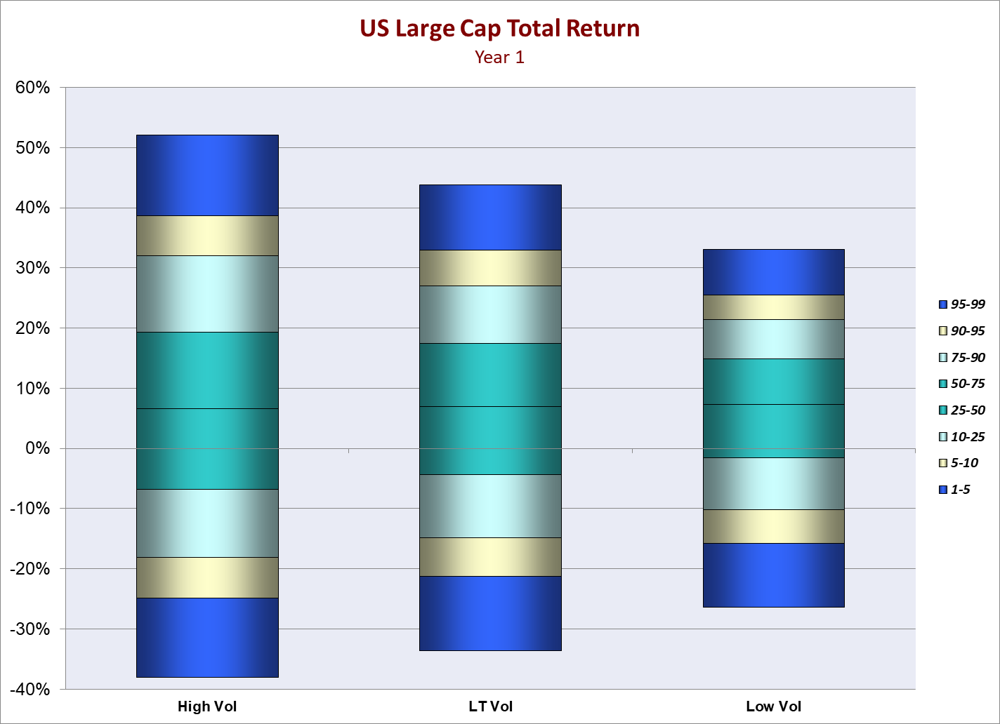
Figure 1: Distribution of Year 1 Total Returns for US Large Cap Returns based on 8/2 Treasury Calibration and alternative initial Volatility levels
Not surprisingly, the strengths and weakness of this approach tend to be the exact opposite of the first one. However, there is one additional concern: Conning will not be able to provide either the data or the methodology to derive this parameter each quarter. This concern leads us to the third option.

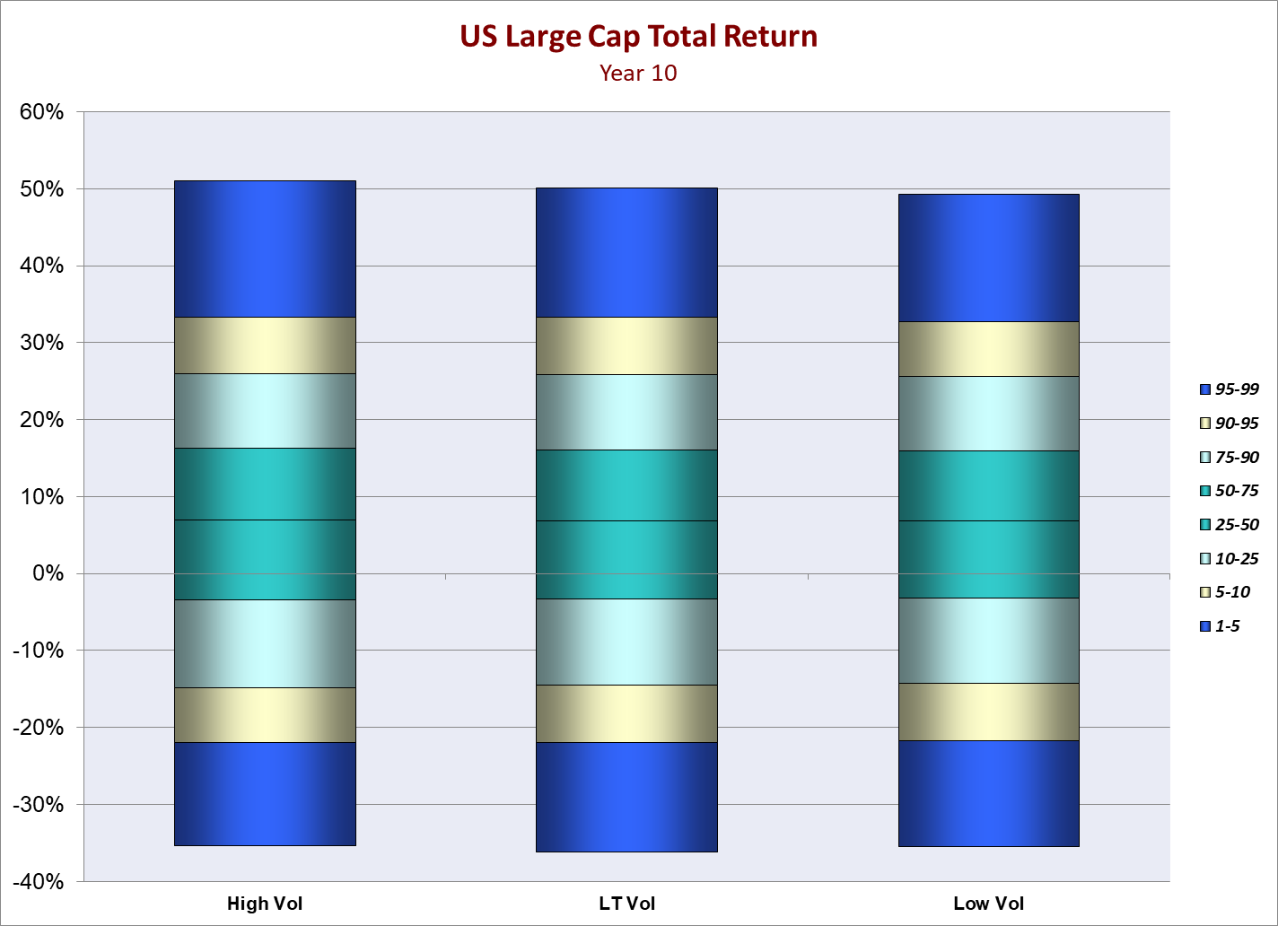
Figure 2: Comparison of Year 10 Total Return distributions for the same simulations as in Figure 1

Use a proxy methodology
In this type of equity model, the daily returns it generates will tend to be more volatile when this volatility parameter gets larger. That means we can use observed market data, such as recent daily trading volatility or VIX levels, as a reasonable proxy for the Conning estimate. For example, in Table 1, we have used the volatility of daily returns over each of these quarters to come up with a linear estimate of the underlying GEMS parameter. Since there is a 90% correlation between the actual GEMS parameter and the observed volatility, albeit over a VERY small sample, the resulting estimates provide a reasonable fit. In particular, since this type of information is generally available, companies and SMEs would be able to independently verify it, unlike the Conning calibration values.

High Vol = 2.1% Initial Volatility, LT Vol = 1.4% Initial Volatility and Low Vol = 0.7% Initial Volatility,
There can be jumps like Black Monday which are more of a one-off event. But those tend to be a relative rarity especially since the jump frequency is also tied to the current volatility level.
We are not recommending using only 6 quarters to fit the proxy model. This is just meant as an example of the potential approach.

