Before You Buy That “Low Cost” Health Insurance:
STOP, CALL, CONFIRM
Know What You’re Buying. Get Advice from a Trusted Source.

To buy insurance that will cover a wide range of conditions, start with the federal Health Insurance Marketplace at www.healthcare.gov [or STATE exchange] or talk to an agent or broker that is licensed in [STATE]. If you have questions, call the [DOI] at [_______]
Open Enrollment for 2021 coverage is from November 1 to December 15 [or STATE OE period]. You may still be able to enroll in comprehensive coverage outside of these dates if you have a qualifying life event, like losing other health coverage, moving, getting married, or having a child. Medicaid is always open to those who qualify.

Financial Help May Be Available
Visit [MARKETPLACE OR EXCHANGE WEBSITE] to learn if you qualify for financial help to pay for Marketplace insurance or if you qualify for low- or no-cost coverage through Medicaid.

You can find brokers, agents and others qualified to review [MARKETPLACE or EXCHANGE] plans at https://localhelp.healthcare.gov/#/
If you found less costly health insurance online or someone called with an offer, here are some questions to ask before you buy. For help, call your state [DOI]:

- Is it a Short-Term, Limited Duration plan, a Sharing Ministry plan, or other limited-coverage plan? Is it sold through an association that requires a membership fee? If so, it could cover less than Marketplace plans.
- Is the person selling the plan licensed in [STATE]? If so, ask for his/her state license number and contact [STATE DOI] at [phone number] to confirm.
- What is the insurance company and is it licensed in [STATE]?
- Does the plan cover your pre-existing conditions? Does it cover your medications?
- What are the deductibles? There may be different deductibles for different services.
- What services DOESN’T the plan cover?
- For services that ARE covered, how much will the plan actually pay? Is there a limit on the total amount the plan will pay per person, per service, or per year?
- How long will the coverage last? Will you be able to keep or renew your coverage if you get sick?
- Does the plan have a provider network?
  - If yes, how do you access information about it? Is your doctor or hospital in the network?
  - If not, will doctors and providers agree not to bill for amounts above what the plan pays?

Ask for a written example of how coverage works if you visited a physician and needed diagnostic tests and follow-up care. Also ask for a written example of how coverage works if you had a hospital stay for several days, and had testing and scans, surgery, and saw several specialists.
Before you buy, always ask for the plan’s details in writing and take the time to review the materials carefully. Don’t feel rushed to make a decision. Remember, there is free help available to you at [NAME OF INSURANCE DEPT WITH PHONE NUMBER].
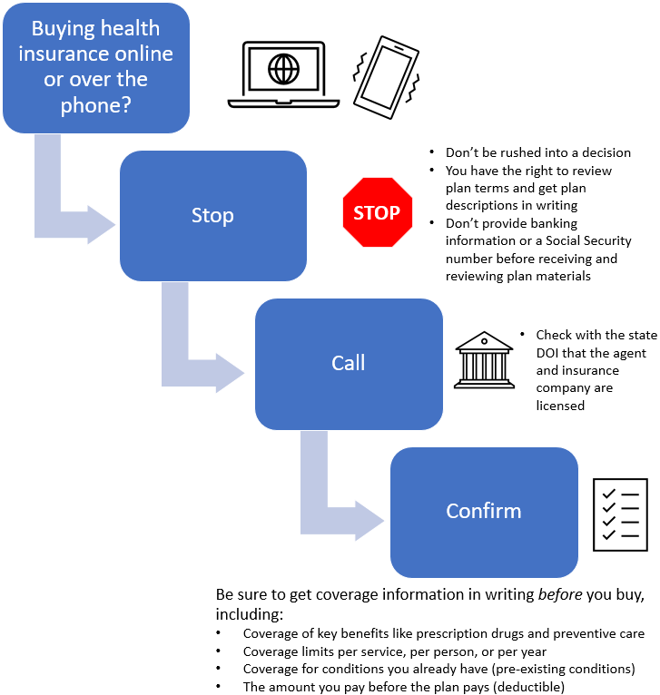
Get more help with these resources from the National Association of Insurance Commissioners

What to Ask When Shopping for Health Insurance

Health Insurance Shopping Tool

