Should Equity Returns and Treasury Yields be related?
Key question: The GEMS Equity model assumes that the expected return on equities is directly related to the current Overnight Treasury Yield. So, if the Treasury curve moves up or down 1%, then the expected returns on equities will move the same amount.

Key facts:
- This relationship applies to expected, not actual, Equity returns
This is the same idea that applies to bonds: when current Yields are higher (say 10%), then we expect Long Treasuries to have relatively strong returns. However, that doesn’t mean we can’t have very bad, even negative, returns when Yields are that high. Just that it’s our expectations that are changing.

- The resulting correlation between Treasuries and Equities will be very small, even with this relationship
In all of the calibrations that we have looked at, the 1-Month Yield has a volatility in the 2 – 3% range at the end of 30 years. At that same point in the simulation, the Large Cap Equity return is expected to have a volatility of at least 15%. Given the large discrepancy in volatilities and that the link is 1-1, this means that the resulting expected correlation between Short Treasuries and Equity Total Returns will be pretty close to 0%, maybe as high as 10%.

- The observed correlation between Treasuries and Equities across individual paths is likely to show heavy fluctuation around its expected level.
In both the AIRG and GEMS model, the Equity returns are much more volatile than the Short Treasury. As a result, we are very likely to see very large swings across an individual path. For example, Figure 1 shows a 10-Year Rolling correlation between these two items for the first 10 paths of the Revised Baseline calibration for December 2020 scenarios (i.e. the ones on Conning’s website). As this graph shows, the observed correlation can be much higher or much lower, sometimes on the same scenario, than the average 3% across the entire simulation.

- Expected Equity returns are NOT observable. Instead, the historical data shows us actual equity returns.
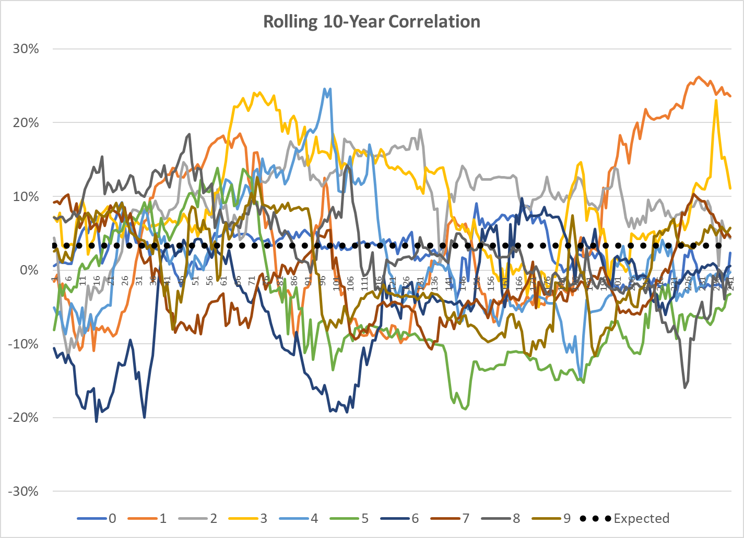
Figure 1: Rolling correlation between US Large Cap Total Returns and 1-Month Treasury Yields from the December 2020 Revised Baseline calibration. The dotted line reflects the average correlation across the entire sample.

Given the large amount of residual volatility in Equity returns, this is a very important distinction. Consider a simple example: we have a single die and we want to know what it’s average value is. However, we don’t know what values are written on each side. We don’t even know how many sides it has! All we get is a single roll. While the result of this “experiment” will be related to the answer we’re looking for, it’s by not how clear how much error there is in the estimate.

A closer approximation might be market participant’s current expectations. This doesn’t suffer from the sampling bias mentioned above. However, that doesn’t mean its perfect either. For example, the usage of these expectations (e.g. pension discounting) may have a large impact on both their value and their stability. There is also no reason to believe that all market participants have the same expectation, which means we may have a different type of sample bias.

- It is not clear if adding this linkage will make the resulting Reserve and Capital calculations more or less volatile
First, it is clear that adding this linkage will make cumulative Equity returns, or wealth factors, more volatile. In the AIRG, the projected Equity returns are the same for each and every start date. With the GEMS linkage, these returns will change each time the Treasury simulations changes (i.e. every start date). Even if we adjust the GEMS parameters to try and minimize this, there will still be run to run differences that are not present in the current AIRG model’s results.
However, for this application, these wealth factors do not directly impact the quantities that we care about: Capital and Reserves. That is because these values occur at some point in the future, but we want to estimate their impact today. We do this by discounting back to T=0, which is where the rub comes in. If the discount rate was deterministic (e.g. 5%), then there would be a 1-1 relationship between these wealth factors and our calculations since we would just be scaling the future results. But, in Life Insurance, we tend to use a discount rate that is stochastic which can change things. Specifically, if the discount factors move in step with the wealth factor changes (e.g. if we discounted with the Overnight Treasury), then the one with a link can produce less sensitive T=0 values. For example, if we discounted these future values based entirely on the actual Large Cap total return, then it wouldn’t matter what the equity return mechanism was: we would always get back a value of 1 at T=0. In practice, the interactions between the scenarios and the reserve and capital standards are complex and will need to be understood through field testing and model office testing.

Given those facts, lets now consider the pros and cons of the two approaches under consideration.
Approach: Assume Equity return are independent of the Treasury market
Pros:
- Aligns with the current AIRG methodology and could therefore produce fewer differences for Reserve and Capital calculations as a result of the implementation of the new ESG
- Easier to produce calibration targets for since they don’t vary by starting condition

Cons:
- Would require recalibration of the GEMS Equity model, especially on the Dividend Yield. It is unclear exactly how much work or how long this process would take.
- Would require additional testing of Conning’s calibration tools for the Equity model
- Would need to be repeated for all 4 native equity models

Approach: Use Conning’s existing relationship
Pros:
- Already built and calibrated
- Aligns with desire to have reasonable risk-reward relationship between Equity and Bond Asset classes
In the AIRG, the expected equity returns are independent of any initial conditions. However, expected Bond returns do fluctuate. As a result, the difference between these two returns will fluctuate with initial conditions. For example, if the Treasury Yields reverted to 1980’s levels (i.e. north of 10%), then expected returns on the Money Market fund would be north of 10% too. However, the US Large Cap would continue to have an expected return of 8.75%. In other words, US Large Cap would have a negative Risk Premium in that situation.

With the GEMS relationship, both expected Bond and Equity returns would change with current Yields. So, in the situation above, the US Large Cap returns would go up just like the Money Market ones. The net result would be a more stable expected Equity Risk Premium

- Aligns with the definition of things like Equity Risk Premium and Sharpe Ratio
The basic premise of the Equity Risk Premium is the excess return that investors require for taking on the riskiness of these investments. It is usually expressed as E[r] – r_{f} where E[r] is the expected return and r_{f} is the Risk-Free rate. The Sharpe Ratio has a similar construct, it just scales the result by the investment’s standard deviation. In either case, the basic assumption of this construct is that expected equity returns are relative to the returns on Treasuries.

- This approach is consistent with the Academy’s original justification for the current expected Large Cap returns
The S&P 500 is the basis of the US Large Cap returns for both the AIRG and GEMS scenarios. Historically, the average annual return on this index has been well north of 10%. But, the average return in the AIRG model was calibrated to 8.75%. Part of the rationale for this lower figure, was the following:
To recognize model risk and parameter uncertainty it was agreed that some constraints should be introduced. For practical reasons, this was accomplished by adjusting the parameters to reduce the expected return. We believe such refinements are consistent with the concept of “prudent best estimate” assumptions and furthermore that the “adjusted” model produces returns that are within the long-term reasonable expectations of practitioners. An unconditional mean total return of 8.75% seemed reasonable for the following reasons:

1. Over the last 50 and 20 years respectively, the average returns on 3-month Treasury bills were approximately 5.30% and 5.15% (annual effective). Hence, taking a long-term perspective (i.e., the forecast horizon is at least 20 years), the range 5 – 5.25% seems sensible for future risk-free rates.

2. A so-called “equity risk premium” (above risk-free rates) in the range 3.5 – 3.75% per annum does not seem excessive given the return characteristics of the equity model (i.e., volatility clustering, negative skewness and positive).

Applying this same logic to the current values would result in an expected return of under 7% based on a target 3% for the 3-Month Yield and the same 3.5 – 3.75% “equity risk premium”.

Cons:
- Likely to be a source of reserve and capital differences from implementation of the new ESG
- Adds additional complexity to the process, especially in terms of understanding why answers change from one date to the next

This only applies directly to the four native equity indices: Large Cap, Mid Cap, Small Cap and Aggressive US Equity. The International Equity indices are expected to be tied to one or more of these indices, so they will likely move, but the movement may not be 1-1.
This assumes that the two distributions: one with a link and one without have a similar mean and standard deviation of future wealth factors.
This was true both now and when the original C3 Phase II calibration was done in 2003.
Page 27 of the AAA C3 Phase 2 Final Report 2005-06 with TOC

