Life Actuarial (A) Task Force
Exposure
2018-44
Re-Exposed 1/21/19 for a 14-day public comment period

Two versions of the APF are included in this exposure. The first version was exposed for comment through Oct. 26, 2018. It proposes using 105% of the hedge budget for years 1-20, in lieu of the economic scenario 12 equity returns, for the deterministic reserve.

The second version of the APF was exposed for comment through Jan. 3, 2019. It proposes using 100% of the hedge budget for years 1-20 and 108% of the hedge budget for years 21+, in lieu of the economic scenario 12 equity returns, for the deterministic reserve.

Both versions propose using the term “cash flows from invested assets” in place of the term “cash flows”.

Please provide comments on which hedge budget percentages seem appropriate and whether the addition of the term “cash flows from invested assets” is necessary and appropriate.

Version 1

Life Actuarial (A) Task Force/ Health Actuarial (B) Task Force
Amendment Proposal Form*

1. Identify yourself, your affiliation and a very brief description (title) of the issue.

Chris Whitney, on behalf of the American Academy of Actuaries’ Life Reserves Work Group.

Revise the approach in VM-20 to determine the credited rate for index accounts in the calculation of the Deterministic Reserve (DR).

2. Identify the document, including the date if the document is “released for comment,” and the location in the document where the amendment is proposed:

2018 edition of the Valuation Manual, updated Nov. 22, 2017; VM-20: Requirements for Principle-based Reserves for Life Products.

3. Show what changes are needed by providing a red-line version of the original verbiage with deletions and identify the verbiage to be deleted, inserted or changed by providing a red-line (turn on “track changes” in Word®) version of the verbiage. (You may do this through an attachment.)

See Attachment A.

4. State the reason for the proposed amendment? (You may do this through an attachment.)

The equity market returns prescribed in the Deterministic Reserve (DR) scenario are based on analysis for variable products. Applying these returns to indexed life products results in very low index credited rates that is not consistent with the intent of the DR scenario (as defined in VM-20) to be a one standard deviation shock from the mean.

Using an index credited rate for the DR scenario consistent with the Implied Guaranteed Rate Method (IGRM) under Actuarial Guideline XXXVI produces moderately adverse index credited rates that are more in line with the intent of the DR scenario and have a more realistic relationship between index credited rates and option budgets.

See Attachment B for further details and supporting analysis.

* This form is not intended for minor corrections, such as formatting, grammar, cross–references or spelling. Those types of changes do not require action by the entire group and may be submitted via letter or email to the NAIC staff support person for the NAIC group where the document originated.
NAIC Staff Comments:

Dates: Received | Reviewed by Staff | Distributed | Considered
Notes: Amendment Proposal 2018-44 re-exposed through 10/26

Attachment A: Proposed changes

Add the following new paragraph #6 under Section 7.F:
F. Cash Flows Invested Assets

- Determine cash flows from invested assets for each projection interval for hedge assets used in the determination of credited amounts for indexed life insurance policies and indexed accounts of other types of life insurance products as follows:

- In lieu of the economic scenario 12 equity returns, as described in Section 7.G.1.a.ii for the deterministic reserve, use 100% of the amount spent on options, accumulated to the end of the option settlement period. The 1-year U.S. Treasury rate will be used for accumulation.

- For the scenarios described in Section 7.G.2 for the stochastic reserve, use scenario equity returns applicable to the underlying basis for credited interest, along with mechanics of the underlying options that reflect caps, floors, and participation rates.

Attachment B: Supporting analysis

Summary
The equity market returns prescribed in the Deterministic Reserve (DR) scenario are based on analysis for variable products. Applying these returns to indexed life products results in very low index credited rates that is not consistent with the intent of the DR scenario (as defined in VM-20) to be a one standard deviation shock from the mean. Using an index credited rate for the DR scenario consistent with the Implied Guaranteed Rate Method (IGRM) under Actuarial Guideline XXXVI produces moderately adverse index credited rates that are more in line with the intent of the DR scenario and demonstrate a more realistic relationship between index credited rates and option budgets.

Analysis
Account performance
The account performance for representative Variable Universal Life (VUL) and Indexed Universal Life (IUL) products was compared using the DR scenario and the 10,000 SR scenarios.
Product details and results from this analysis are summarized in the following table.
 |  | Projection year 1-20 |  | Projection year 1-30
 |  | VUL | IUL | VUL | IUL
Index Parameters | Dividends | Yes | No | Yes | No
 | Cap | n/a | Dynamic* | n/a | Dynamic*
 | Guaranteed Cap | n/a | 3.0% | n/a | 3.0%
10,000 SR Scenarios | Mean | 7.7% | 5.8% | 7.6% | 5.9%
 | SD | 3.6% | 1.7% | 3.0% | 1.5%
 | Minimum | -4.4% | 1.4% | -2.5% | 1.7%
 | Maximum | 20.3% | 15.3% | 19.2% | 12.3%
DR Scenario—Current | Rate | 4.0% | 2.0% | 5.2% | 3.2%
 | SDs From Mean | -1.0 | -2.2 | -0.8 | -1.8
DR Scenario—100% OB | Rate |  | 4.0% |  | 4.1%
 | SDs From Mean |  | -1.0 |  | -1.2
DR Scenario—105% OB | Rate |  | 4.3% |  | 4.3%
 | SDs From Mean |  | -0.9 |  | -1.0
DR Scenario—112% OB | Rate |  |  |  | 4.7%
 | SDs From Mean |  |  |  | -0.8
* The dynamic cap is based on the projected earned rate for each scenario.
Variable account (VUL product)
Performance for the DR scenario is 1.0 standard deviation below the average of SR scenarios in projection years 1-20. This is in line with the DR scenario description shown in the “Background” section of this attachment.
When looking over projection years 1-30, the performance for the DR scenario is -0.8 standard deviation below the average of SR scenarios. The returns are higher in years 20-30 because the return shocks only apply for the first 20 years.
Index account (IUL product)
Account performance for the DR scenario under the current approach is 2.2 standard deviations below the average of SR scenarios in projection years 1-20 and 1.8 standard deviations in projection years 1-30, which is extremely low when considering the description of the DR scenario.
The recommended change to the DR scenario brings the index account performance in line with the variable account in projection years 1-20, with performance 1.0 standard deviations below the average of the SR scenarios. This relationship does not hold beyond year 20 because the recommendation does not consider the lack of return shocks beyond year 20, and the index account performance falls below the variable account.

Equity growth rates
Considerations and analysis around equity growth rates were presented at the Spring NAIC meeting.
The file below contains a comparison of the option return and option budgets for the DR scenario using the current and proposed approach for a variety of different cap rates.
The results demonstrate that the proposed approach has the desired effect of linking the option return to the option budget for the DR scenario. The results are shown in the following graph, taken from this file.
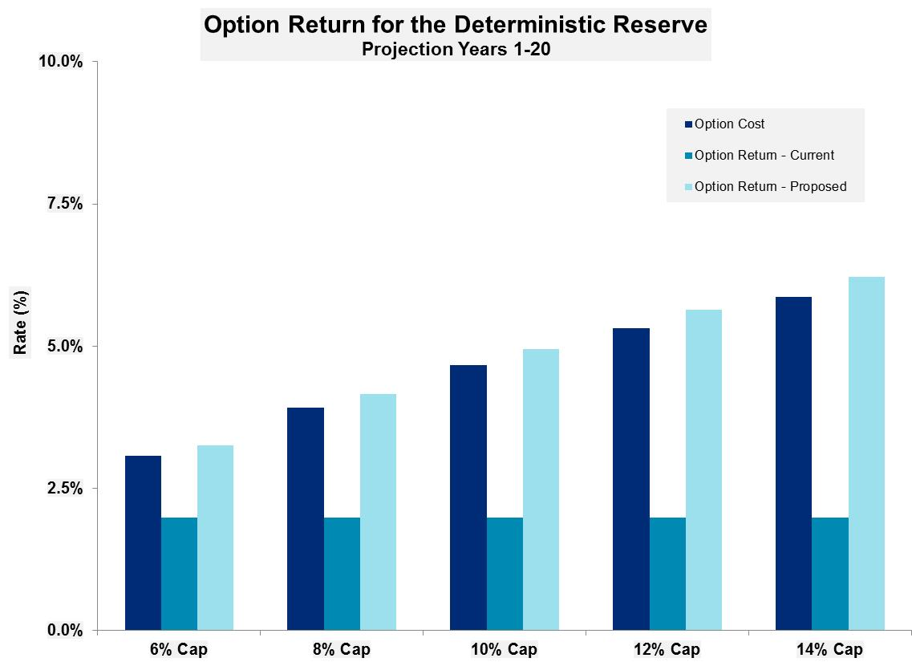

Background information
DR equity returns
The equity market returns for the DR scenario are based on analysis performed for variable products by the American Academy of Actuaries’ Variable Universal Life Subgroup.
The scenario used for the DR is described in Section 7.G.1.c of VM-20 as: “…interest rate yield curves and total investment returns are based on approximately a one standard deviation shock to the economic conditions as of the projection start date, where the shock is spread uniformly over the first 20 years of the projection.”
Actuarial Guideline XXXVI
The IGRM under Actuarial Guideline XXXVI defines the guaranteed rate as: (a) the guaranteed interest rate for the current term of the contract; plus (b) the accumulated option cost expressed as a percent of the policy value to which the indexed benefit is to be applied.
The option cost as of the valuation date uses the currently declared cap rate. For periods past the valuation date, the guaranteed minimum cap rate is used.

Life Actuarial (A) Task Force/ Health Actuarial (B) Task Force
Amendment Proposal Form*

1. Identify yourself, your affiliation and a very brief description (title) of the issue.

Chris Whitney, on behalf of the American Academy of Actuaries’ Life Reserves Work Group.

Revise the approach in VM-20 to determine the return on assets used in the hedging of credited amounts for indexed accounts in the calculation of the Deterministic Reserve (DR).

2. Identify the document, including the date if the document is “released for comment,” and the location in the document where the amendment is proposed:

2018 edition of the Valuation Manual, updated Nov. 22, 2017; VM-20: Requirements for Principle-based Reserves for Life Products.

3. Show what changes are needed by providing a red-line version of the original verbiage with deletions and identify the verbiage to be deleted, inserted or changed by providing a red-line (turn on “track changes” in Word®) version of the verbiage. (You may do this through an attachment.)

See Attachment A.

4. State the reason for the proposed amendment? (You may do this through an attachment.)

The equity market returns prescribed in the Deterministic Reserve (DR) scenario are based on analysis for variable products. Applying these returns to indexed accounts within life products results in very low index credited rates that is not consistent with the intent of the DR scenario (as defined in VM-20) to be a one standard deviation shock from the mean for the first twenty years from the valuation date, followed by a return to normal.

Using an index credited rate for the DR scenario consistent with the Implied Guaranteed Rate Method (IGRM) under Actuarial Guideline XXXVI produces moderately adverse index credited rates that are more in line with the intent of the DR scenario and have a more realistic relationship between index credited rates and option budgets.

See Attachment B for further details and supporting analysis.

* This form is not intended for minor corrections, such as formatting, grammar, cross–references or spelling. Those types of changes do not require action by the entire group and may be submitted via letter or email to the NAIC staff support person for the NAIC group where the document originated.
NAIC Staff Comments:

Dates: Received | Reviewed by Staff | Distributed | Considered
Notes: Revised Amendment Proposal 2018-44

Attachment A: Proposed changes

Insert the following new paragraph #4 under Section 7.F:
F. Cash Flows from Invested Assets

- Determine cash flows from invested assets for each projection interval for assets used in the hedging of credited amounts for indexed accounts within life insurance products (including indexed life products and indexed accounts within other types of life insurance products) as follows:

- In lieu of the economic scenario 12 equity returns, as described in Section 7.G.1.a.ii for the deterministic reserve, use X% of the amount spent on options, accumulated to the end of the option settlement period; where X is equal to 100% in projection years 1-20 and 108% in projection years 21+. The 1-year U.S. Treasury rate from scenario 12 applicable to the projection year will be used for accumulation.

- For the scenarios described in Section 7.G.2 for the stochastic reserve, use scenario equity returns applicable to the underlying basis for credited interest, along with mechanics of the underlying options that reflect caps, floors, and participation rates.

- Determine cash flows from invested assets for each projection interval for all other general account assets by modeling asset cash flows on other assets that are not described in subsections 7.F.1 through 7.F.4 using methods consistent with the methods described in subsections 7.F.1 and 7.F.2. This includes assets that are a hybrid of fixed income and equity investments.

- Determine cash flows from invested assets as appropriate for each projection interval for all separate account assets in a manner that is consistent with the prescribed separate account asset returns described in Section 7.G.

G. Economic Scenarios

1. Deterministic Economic Scenarios

a. For purposes of calculating the deterministic reserve under Section 4, the company shall use:

i. U.S. Treasury interest rate curves following Scenario 12 from the set of prescribed scenarios used in the stochastic exclusion ratio test defined in Section 6.B; and

ii. Total investment return paths for general account equity assets (excluding assets used in the hedging of credited amounts for indexed accounts as described in Section 7.F.4) and separate account fund performance consistent with the total investment returns for corresponding investment categories contained in Scenario 12 from the set of prescribed scenarios used in the stochastic exclusion ratio test defined in Section 6.B.

Guidance Note: Where the NGE being projected is based on cash flows from invested assets, the cash flows from invested assets should be determined first, following Section 7.F.]

Attachment B: Supporting analysis

Summary
The equity market returns prescribed in the Deterministic Reserve (DR) scenario are based on analysis for variable products. Applying these returns to indexed accounts within life products results in very low index credited rates that is not consistent with the intent of the DR scenario (as defined in VM-20) to be a one standard deviation shock from the mean for the first 20 projection years. Using an index credited rate for the DR scenario consistent with the Implied Guaranteed Rate Method (IGRM) under Actuarial Guideline XXXVI produces moderately adverse index credited rates that are more in line with the intent of the DR scenario and demonstrate a more realistic relationship between index credited rates and option budgets.

Analysis
Account performance
The account performance for representative Variable and Indexed account deposits was compared using the DR scenario and 1,000 SR scenarios.
Product details and results from this analysis are summarized in the following table.
 |  | Projection year 1-20 |  | Projection year 21+
 |  | Variable | Indexed | Variable | Indexed
Index Parameters | Dividends | Yes | No | Yes | No
 | Cap | n/a | Dynamic* | n/a | Dynamic*
 | Guaranteed Cap | n/a | n/a | n/a | n/a
1,000 SR Scenarios | Mean | 7.4% | 3.4% | 7.5% | 4.0%
 | SD | 3.6% | 0.8% | 3.1% | 1.0%
 | Minimum | -3.5% | 1.9% | -1.9% | 2.2%
 | Maximum | 18.5% | 6.3% | 17.7% | 7.0%
DR Scenario—Current | Rate | 4.0% | 2.0% | 7.7% | 5.4%
 | SDs From Mean | -1.0 | -2.2 | 0.0 | 1.4
DR Scenario—100% OB | Rate |  | 2.6% |  | 3.7%
 | SDs From Mean |  | -1.0 |  | -0.2
DR Scenario—108% OB | Rate |  |  |  | 4.0%
 | SDs From Mean |  |  |  | 0.0
* The dynamic cap is based on the projected earned rate for each scenario.
Variable account (VUL product)
Performance for the DR scenario is 1.0 standard deviations below the average of SR scenarios in projection years 1-20 and in line with the average of SR scenarios in projection years 20-50. This is consistent with the DR scenario description shown in the “Background” section of this attachment.
Index account
Account performance for the DR scenario under the current approach is 2.2 standard deviations below the average of SR scenarios in projection years 1-20 and 1.4 standard deviations above the average in projection years 20-50. When considering the description of the DR scenario, this results in extremely low index credits in the first 20 projection years followed by index credits that are too high beyond projection year 20.
The recommended change to the DR scenario brings the index account performance in line with the variable account in projection in all years, with performance 1.0 standard deviations below the average of the SR scenarios for the first 20 projection years and in line with the average beyond projection year 20.

Equity growth rates
Considerations and analysis around equity growth rates were presented at the Spring NAIC meeting.
The file below contains a comparison of the option return and option budgets for the DR scenario using the current and proposed approach for a variety of different cap rates.
The results demonstrate that the proposed approach has the desired effect of linking the option return to the option budget for the DR scenario. The results are shown in the following graph, taken from this file.

Background information
DR equity returns
The equity market returns for the DR scenario are based on analysis performed for variable products by the American Academy of Actuaries’ Variable Universal Life Subgroup.
The scenario used for the DR is described in Section 7.G.1.c of VM-20 as: “…interest rate yield curves and total investment returns are based on approximately a one standard deviation shock to the economic conditions as of the projection start date, where the shock is spread uniformly over the first 20 years of the projection.”

Actuarial Guideline XXXVI
The IGRM under Actuarial Guideline XXXVI defines the guaranteed rate as: (a) the guaranteed interest rate for the current term of the contract; plus (b) the accumulated option cost expressed as a percent of the policy value to which the indexed benefit is to be applied.
The option cost as of the valuation date uses the currently declared cap rate. For periods past the valuation date, the guaranteed minimum cap rate is used.

The presentation can be found at actuary.org/files/publications/Academy_IUL_under_PBR_for_NAIC_Spring_2018.pdf.
The presentation can be found at actuary.org/files/publications/Academy_IUL_under_PBR_for_NAIC_Spring_2018.pdf.

