Exposure of APF 2019-51
ACLI Non-Material VA Edits

Exposed for public comment through May 14, 2019
Comments can be sent to Reggie Mazyck (RMazyck@NAIC.Org)

Brian Bayerle
Sr. Actuary

John Bruins
Consultant

March 29, 2019

Mr. Mike Boerner
Chair – NAIC Life Actuarial Task Force

Re: Non-material Edits to VA Documents

Dear Mr. Boerner:

The ACLI is pleased to submit the following additional comments to document a series of suggested edits to the various exposed documents for the implementation of the VA Framework that we see as non-material clarifications. For each, we see these as clarifying, but not changing, the requirements as exposed. We will separately provide to staff a list of spelling, punctuation, formatting, cross reference and similar issues that we have noted during our review.

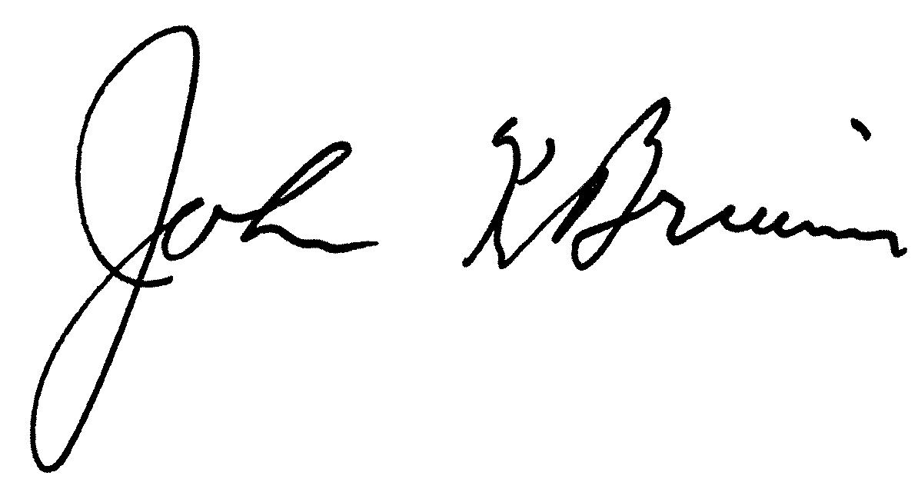
Very truly yours,
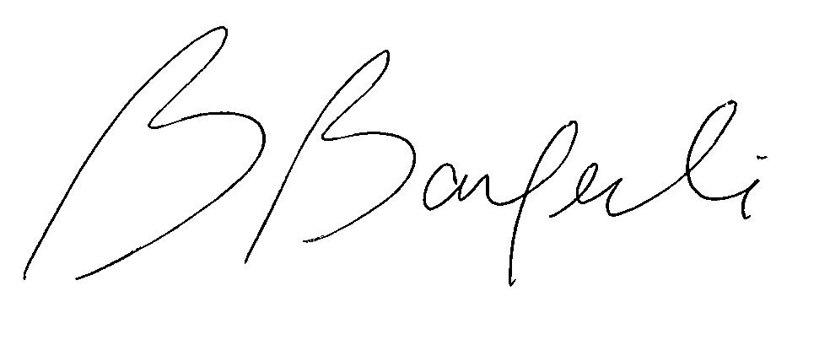

Brian Bayerle John Bruins
Senior Actuary Consultant
202-624-2169 410-991-3996
brianbayerle@acli.com jbruins.fsa@gmail.com

cc: Reggie Mazyck, NAIC
Pete Weber, Ohio

Document | Page | Citation | Edit | Comments / Rationale
VM-01 | 01-2 | CDHS | - The term “clearly defined hedging strategy” means a strategy undertaken by a company to manage risks through the future purchase or sale of hedging instruments and the opening and closing of hedging positions that meet the criteria specified in the applicable reserve requirement section of the Valuation Manual. | More precise language
VM-01 | 01-4 | GMDB | - in the case of an annuity providing income payments, guarantees payment upon such death of an amount payable in addition to the continuation of any guaranteed income payments. | Redundant reference to death
VM-21 | 21-1 | 1.A. (GN) | Reserves for contracts subject to VM-21 or AG 43 may be computed . . . | More precise language
VM-21 | 21-1 | 1.A  (G.N.) | (Guidance Note) …issued prior to January 1, 2017 that would not otherwise be encompassed by the scope of VM-21. | Correction
VM-21 | 21-2 | Principle 2: | The methodology uses a projected total cash flow analysis including all projected income . . . | Reflects underlying basis of new Framework, reflecting elimination of the working reserve.
VM-21 | 21-5 | 1.D.3. | Move paragraph 3 to follow the Guidance Note, which applies to definition #2. | Clarify intent
VM-21 | 21-7 | 3.A. | The aggregate reserve for contracts falling within the scope of these requirements shall equal the stochastic reserve (following the requirements of Section 4) plus the additional standard projection amount (following the requirements of Section 6) less any allocable PIMR for all contracts not valued under the Alternative Methodology (Section 7), plus the reserve for any contracts determined using the Alternative Methodology (following the requirements of Section 7). | - PIMR is a defined term and does not need to be redefined.  - Agreement was reached that AVR is excluded until there is a decision to include.
VM-21 | 21-8 | 3.C. | The additional standard projection amount is an additive factor, determined by applying one of the two standard projection methods defined in Section 6, that is added to the stochastic reserve to determine the aggregate reserve. The same method must be used for all contracts within a group of contracts that are aggregated together to determine the reserve, and the additional standard projection amount does not include any contracts whose reserve is determined using the Alternative Methodology. | Clarification
VM-21 | 21-8 | 3.D. | The stochastic reserve may be determined in aggregate for all contracts falling within the scope of these requirements (i.e., a single model segment) or, at the option of the company, it may be determined by subgroupings of contracts into multiple model segments, in which case the stochastic reserve shall equal the sum of the amounts computed for each model segment. | Use defined term “model segment”
VM-21 | 21-8 | 3.G. | The portion of the aggregate reserve held in the general account shall not be less than the excess of the aggregate reserve over the aggregate cash surrender value held in the separate account and attributable to the separate account portion of all such contracts. | More precise language
VM-21 | 21-9 | 3.H. | For each model segment, a qualified actuary to whom responsibility for the model segment is assigned shall document the development of the reserves and provide the required certifications following the requirements of VM-31. | Use of defined term
VM-21 | 21-9 | 4.A.1. | (last sentence) Accumulated deficiencies shall be determined at the end of each projection year as the sum of the accumulated deficiencies for all contracts within each model segment | Use of defined term
VM-21 | 21-9 | 4.A.3. | Model Cells | Distinguish model construction from model segments.
VM-21 | 21-13 | 4.B.1. | When using the direct iteration method, the scenario reserve will equal the final starting asset amount determined according to Section 4.B.4. | Redundant reference.
VM-21 | 21-14 | 4.B.4. | . . . projection horizon with no accumulated deficiencies at the end of any projection year during the projection period. | More precise language
VM-21 | 21-14 | 4.D.1.a.ii. | - Any hedge instruments held in support of the contracts being valued; and | Language consistent with current VM-21
VM-21 | 21-16 | 4.D.4.b. | Move sentence following the Guidance Note to be part of the preceding paragraph. | Improve readability
VM-21 | 21-19 | 5.A.3. | Reserve Determined using the Alternative Methodology | No longer applicable
VM-21 | 21-20 | 6.A.1.a. | a. The additional standard projection amount shall be determined in aggregate for all contracts falling under the scope of these requirements, excluding those contracts to which the Alternative Methodology is applied, by calculating the Prescribed Projections Amount by one of two methods, the Company-Specific Market Path (CSMP) method or the CTE with Prescribed Assumptions (CTEPA) method . | Correction of method reference
VM-21 | 21-20 | 6.A.2. | Move this entire paragraph to become 6.B.2., then renumber the remaining paragraphs of 6.B. | Improve readability
VM-21 | 21-21 | 6.B.3. | 3. Calculation Methodology  a. The company shall determine the Prescribed Projections Amount by following either the CSMP Method or the CTEPA Method below. A company may not change the method used from one valuation to the next without approval of the domiciliary commissioner.  i CSMP Method:  1. Calculate the scenario reserve, as defined in VM-01 and discussed further in Section 4.B, for each of the prescribed market paths outlined in Section 6.B.5 using the same method and assumptions as those that the company uses to calculate scenario reserves for purposes of determining the CTE70 (adjusted) , as outlined in Section 9.C. These scenario reserves shall collectively be referred to as Company Standard Projection Set;  2. Identify the market path from the Company Standard Projection Set such that the scenario reserve is closest to the CTE70 (adjusted), designated as Path A. This scenario reserve shall be referred to as Company Amount A;  3. Identify the following four market paths:  - two paths with the same starting interest rate as Path A but equity shocks +/- 5% from that of Path A, and.  - two paths with the same equity fund returns as Path A but the next higher and next lower interest rate shocks.  From the four paths, identify Path B whose reserve value is:  - If Company Amount A is lower than CTE70 (adjusted), the smallest reserve value that is greater than CTE70 (adjusted);  - If Company Amount A is greater that CTE70 (adjusted), the greatest reserve value that is less than CTE70 (adjusted).  If none of the 4 paths satisfy the stated condition, discard the identified Path A, and redo steps 2 and 3 using the scenario next closer to CTE70 (adjusted) to be the new Path A in step 2.  For the path so designated as Path B, the scenario reserve shall be referred to as Company Amount B;  4. Recalculate the scenario reserves for Path A and Path B using the same method as outlined in step 1 above but substituting the assumptions prescribed in Section 6.C. and using the modeled in force prescribed by Section 6.B.2.. These scenario reserves shall be referred to as Prescribed Amount A and Prescribed Amount B, respectively;  5. Calculate the Prescribed Projections Amount as:  Prescribed Projections Amount  =Prescribed Amount A + (CTE70 (adjusted) − Company Amount A)  × $\left(\frac{Prescribed Amount B-Prescribed Amount. A}{Company Amount. B-Company Amount. A}\right)$  ii. CTEPA Method:  Calculate the Prescribed Projections Amount as the CTE70 (adjusted) using the same method as that outlined in Section 9.C (or the stochastic reserves following Section 4.A.4.a for a company that does not have a CDHS) but substituting the assumptions prescribed by Section 6.C. The calculation of this Prescribed Projections Amount also requires that the scenario reserve for any given scenario be equal to or in excess of the cash surrender value in aggregate on the valuation date for the group of contracts modeled in the projection.  b. Once the Prescribed Projections Amount is determined by one of the two methodologies above, then the company shall  reduce the Prescribed Projections Amount by the CTE70 (adjusted). The difference shall be referred to as the Unbuffered Additional Standard Projection Amount;  c. Reduce the Unbuffered Additional Standard Projection Amount by an amount equal to the difference between i and ii, where i and ii are calculated in the following manner:  - Calculate the Unfloored CTE70 (adjusted), using the same procedure as CTE70(adjusted) but without requiring that the scenario reserve for any scenario be no less than the cash surrender value in aggregate on the valuation date  - Calculate the Unfloored CTE65 (adjusted), which is calculated in the same way as Unfloored CTE70 (adjusted) but averaging the 35 percent (instead of 30 percent) largest values  d. The additional standard projection amount shall subsequently be the larger of the quantity calculated in Section 6.B.3.c. and zero. | Improve readability
VM-21 | 21-25 | 6.B.5.c. | In the table, for Fixed account returns:  For reinsurers that do not have visibility into the ceding company’s general account earned rate, the company shall project the ceding company’s general account earned rate as the 5-year trailing average of the 5-year U.S. Treasury rate, plus an earned spread of 100 bps per annum. | Clarification
VM-21 | 21-25 | 6.C.1.b | Certain VAGLB products have features that can be described by multiple types of guaranteed benefits. If the VAGLB can be described by more than one of the definitions in VM-01 for the purpose of determining the additional standard projection amount, the company shall select the guaranteed benefit type that it deems best applicable and shall be consistent in its selection from one valuation to the next. For instance, if a VAGLB has both lifetime GMWB and non-lifetime GMWB features and the company determines the lifetime GMWB is the most prominent component, assumptions for all contracts with such a VAGLB shall be set as if the VAGLB were only a lifetime GMWB and did not contain any of the non-lifetime GMWB features. If the company determines the non-lifetime GMWB is the most prominent component, assumptions for all contracts with such a VAGLB shall be set as if the VAGLB were only a non-lifetime GMWB and did not contain any of the lifetime GMWB features. | Clarification
VM-21 | 21-26 | 6.C.1.c | If a contract cannot be classified into any categories within a given assumption the company shall determine the defined benefit type with the most similar benefits and risk profile as the company’s benefit and utilize the assumption prescribed for this benefit. | Clarification
VM-21 | 21-27 | 6.C.4. | (second paragraph)  For any contract not on an automatic withdrawal provision as described in the preceding paragraph, depending on the guaranteed benefit type, other partial withdrawals shall be . . . | Clarification of intent based on discussion with Oliver Wyman
VM-21 | 21-29 | 6.C.4.k | The identification as a simple 403(b) contract should supersede the presence of other guaranteed benefits so move this entire paragraph to become 6.C.4.a, then renumber the remaining paragraphs of 6.C.4. | Clarification
VM-21 | 21-30 | 6.C.6. | In the last paragraph on the bottom of 21-30 and onto the next page, edit as:  For GMWB or hybrid GMIB contracts, for all contract years in which a withdrawal is projected, the full surrender rate obtained from the Standard Table for Full Surrender shall be multiplied by 60%. | Clarification of intent based on discussion with Oliver Wyman
VM-21 | 21-37 | 6.C.11.d | For GMWB or hybrid GMIB contracts, for all contract years in which a withdrawal is projected, the termination rate obtained from Table I shall be additionally multiplied by 60%. | Clarification of intent based on discussion with Oliver Wyman
VM-21 | 21-59 | 9.A.1. | Subject to the guidance in Section 9.C.2., the appropriate costs and benefits of hedging instruments that are currently held by the company in support of the contracts falling under the scope of these requirements shall be included in the calculation of the stochastic reserve, determined in accordance with Section 3.D and Section 4.D. | Redundant with other references, including the definition of CDHS
VM-31 | 31-27 | 3.F.9.d. | Section F. - Documentation of Model Time Step  We recommend that the documentation of the model time step be moved from VM-31 Section 3.F.9.d. to be inserted in Section 3.F.2. following d. It seems more logical to discuss time step as part of the model documentation, along with time horizon and approximations. We also suggest rewording as:  Time-Step – Identification of the time-steps used in the model (e.g., monthly, quarterly, annual). If annual time steps are used, discuss how lack of sensitivity to frequency was validated, including a display of results of any testing performed, as discussed in VM-21 Section 8.G.1. | Clarification

The American Council of Life Insurers (ACLI) advocates on behalf of 290 member companies dedicated to providing products and services that promote consumers’ financial and retirement security. ACLI represents member companies in state, federal and international forums for public policy that supports the industry marketplace and the 90 million families that rely on life insurers’ products for peace of mind. ACLI members represent 95 percent of industry assets in the United States.
Deferred hedge gains/losses developed under SSAP108 are not included in the value of the starting assets.
Throughout this Section 6, references to CTE70 (adjusted) shall also mean the Stochastic Reserve for a company that does not have a CDHS as discussed in Section 4.A.4.a.

